Interpolation in angular

**Description**:  
Interpolation is a feature in Angular that allows you to embed dynamic values in the HTML template. It is used to display data from the component to the view.

**Syntax**:

{{ expression }}

* **Expression**: The expression within the double curly braces is evaluated and the result is displayed in the template.

**Key Points:**

* The expression inside the curly braces is evaluated in the component context.
* It is commonly used to display data from the component's properties or methods.
* You can perform simple expressions, such as string concatenation, arithmetic operations, etc.

**Examples:**

**1. Displaying Component Property:**

<!-- Component Template -->

<p>{{ name }}</p>

In the component:

export class AppComponent {

name = 'Angular';

}

**Output**:

Angular

**2. String Interpolation:**

<!-- Component Template -->

<p>{{ 'Hello, ' + name }}</p>

In the component:

export class AppComponent {

name = 'Angular';

}

**Output**:

Hello, Angular

**3. Arithmetic Operations:**

<!-- Component Template -->

<p>{{ 5 + 3 }}</p>

**Output**:

8

**4. Method Call:**

<!-- Component Template -->

<p>{{ getGreeting() }}</p>

In the component:

export class AppComponent {

getGreeting() {

return 'Hello from the method!';

}

}

**Output**:

Hello from the method!

**5. Binding to HTML Attributes:**

You can also use interpolation for binding to attributes:

<!-- Component Template -->

<img [src]="{{ imageUrl }}">

In the component:

export class AppComponent {

imageUrl = 'https://example.com/image.jpg';

}

# Practical example

* Ts page contains the variables and values

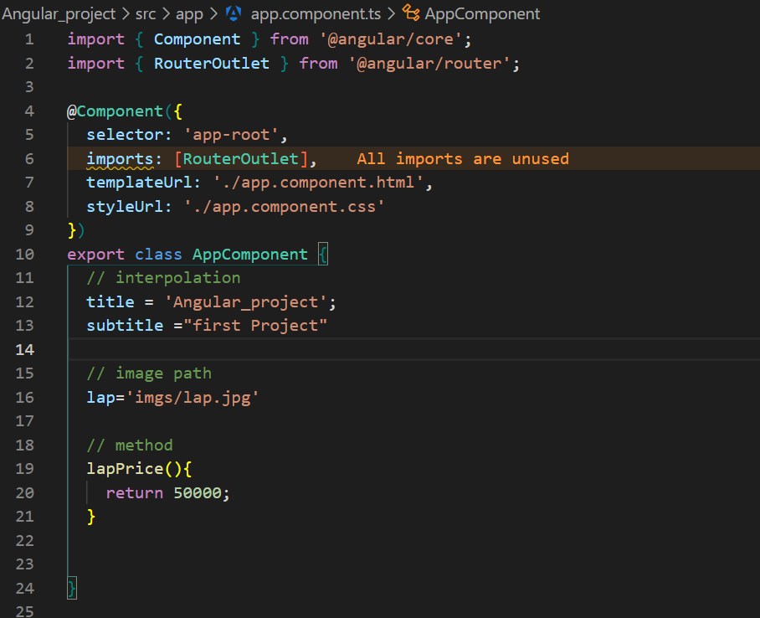

* HTML is calling the values

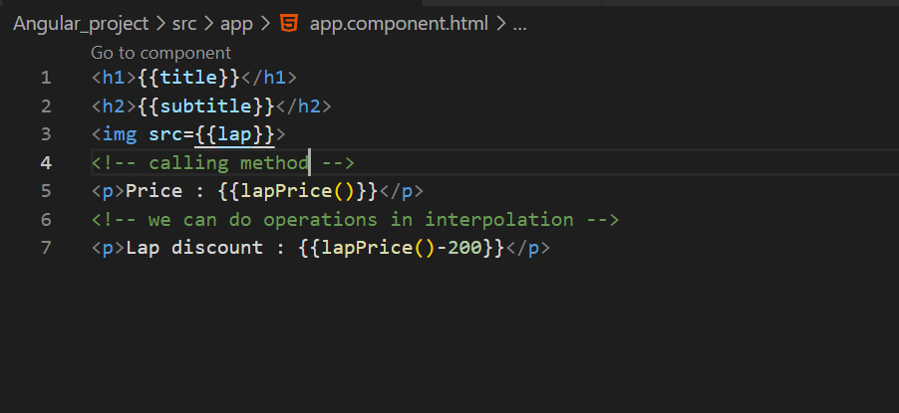

* The lap image should be stored at the **public>imgs(create)>lap.jpg**

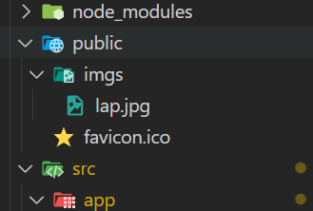

OutPut :

